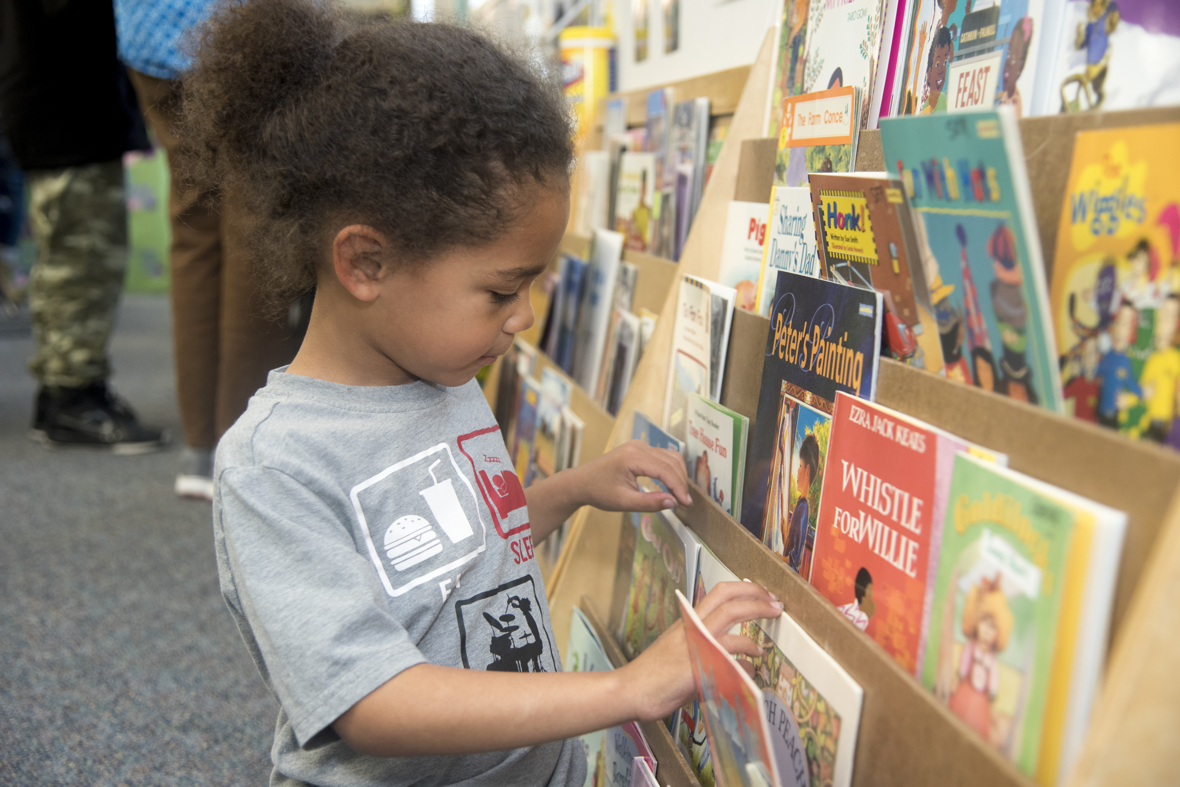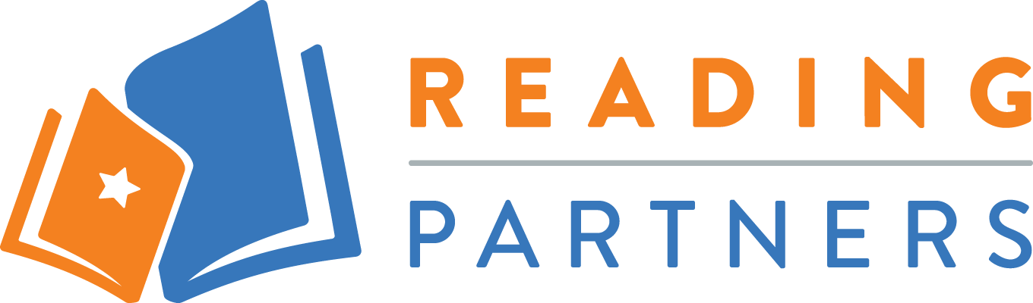

Interested in volunteering or making a donation to Reading Partners? **Visit readingpartners.org**

* Matt de la Peña
* Eric Carle
* Kevin Henkes
* Lio Lionni
* Bill Martin Jr.
* Maurice Sendak
* P.D. Eastman

**RECOMENDED AUTHORS**

**Reading Partners** is an education nonprofit that partners with students, families, schools, and communities to provide students with individualized literacy support and the foundational skills they need to read at grade level by fourth grade.

Through Reading Partners' “Take Reading With You” program, students receive new or very gently used books. These texts help students continue on their learning journeys, building a love of learning while building their personal libraries.

*Communities thrive when all   
students have access to*   
*high-quality learning materials.*

**SUGGESTED BOOKS**

* Multicultural books and books featuring diverse characters (ages 5-9)
* Books for beginning readers
* Award-winning books
* Graphic novels for grades 3 and 4 such as *Dogman*/*Diary of a Wimpy Kid*/*Dork Diaries*
* Non-fiction texts focused on animals, sports, science, Black History, etc.

***Donate new or gently used children’s books and make***

***a difference in your community***

**Reading Partners Book Drive**